### Preparazione:

### Data Engineering(20%)

focused are S3, EMR,Kinesis, Kinesis FireHose, Kinesis Analytics ,Athena and Glue

### Exploratory Data Analysis(24 %)

understanding box plot, line chart, scatter plot, heat map, word cloud, pie chart, pivot table and many more.

### Modeling(36%)

Try to pick which machine learning algorithm to use for particular scenario

Try to know list of all built in algorithms supported by AWS Sage maker as you may be tested to pick which SageMaker algorithm to use.

Try to understand list of hyper parameters that can be optimized for each popular machine and deep learning algorithms.

Get to know about all the popular data preprocessing and feature engineering tasks like normalization, different types of imputation, outlier detection and many more.

Get to know use cases for CNN(Convolutional Neural Networks) and RNN(Recurrent Neural Networks)

Get to know how to optimize deep learning models using number of epochs and number of layers

Get to know how to solve the problem using combination of models like first use kmeans clustering and PCA and then feed the data to classification

### Machine Learning Implementation and Operations(20 %)

this section touches many AWS ML services. You should have understanding on AWS ML application services like transcribe, translate, comprehend, polly, lex. If there is one AWS service you should understand end to end it is SageMaker. Get to know the different features of sage maker like how to use notebook instances, how to create training jobs, How to deploy endpoints, High availability of endpoints, Blue Green deployment endpoints , suitable instances for model training and deployment.

# Datawhareshousing

# EMR  Hadoop-based technologies like Apache Hive

# Amazon Redshift You can also use a columnar MPP data warehouse like Amazon Redshift. These systems make it simple to run complex analytic queries with orders of magnitude faster performance for joins and aggregations performed over large datasets. Amazon Redshift, in particular, leverages high-performance local disks, sophisticated query execution. and join-optimized data formats. Because it is just standard SQL, you can keep using your existing ETL and BI tools. But you do have to load data, and you have to provision clusters against the storage and CPU requirements you need.

**Redshift Spectrum**, Amazon Redshift customers can easily query their data in Amazon S3.  Spectrum needs a Redshift cluster in place. If you are using Redshift database then it will be wise to use Spectrum along with redshift to get the required performance.

### Amazon Athena query su file di testo su s3 [Amazon Athena](https://aws.amazon.com/it/athena/) è il modo più semplice per consentire ai dipendenti di eseguire query ad hoc sui dati in Amazon S3. Athena è un servizio serverless, Athena Has A REST API

# SAGEMAKER Algoritms

For training and hosting Amazon SageMaker algorithms, we recommend using the following EC2 instance types:

* ml.m4.xlarge, ml.m4.4xlarge, and ml.m4.10xlarge Standard cpu
* ml.c4.xlarge, ml.c4.2xlarge, and ml.c4.8xlarge Compute Optimized  (CPU ma high net)
* ml.p2.xlarge, ml.p2.8xlarge, and ml.p2.16xlarge Accelerated Computing (gpu)

### PCA

PCA is an unsupervised machine learning (like clustering) algorithm that attempts to reduce the dimensionality (number of features) within a dataset while still retaining as much information as possible. PCA supports both GPU and CPU computation.

PCA operates in two modes, depending on the scenario:

* **regular**: For datasets with sparse data and a moderate number of observations and features.
* **randomized**: For datasets with both a large number of observations and features. This mode uses an approximation algorithm.

### Sequence to Sequence

Amazon SageMaker Sequence to Sequence is a supervised learning algorithm where the input is a sequence of tokens (for example, text, audio) and the output generated is another sequence of tokens. Example applications include: machine translation (input a sentence from one language and predict what that sentence would be in another language), text summarization (input a longer string of words and predict a shorter string of words that is a summary), speech-to-text (audio clips converted into output sentences in tokens). SageMaker seq2seq is only supported on GPU instance

### BlazingText

The Amazon SageMaker BlazingText supervised algorithm provides highly optimized implementations of the Word2vec and text classification algorithms. The Word2vec algorithm is useful for many downstream natural language processing (NLP) tasks, such as sentiment analysis, named entity recognition, machine translation, etc. Text classification is an important task for applications that perform web searches, information retrieval, ranking, and document classification.

### DeepAR Forecasting

The Amazon SageMaker DeepAR forecasting algorithm is a supervised learning algorithm for forecasting scalar (one-dimensional) time series using recurrent neural networks (RNN).

### Factorization Machines

A factorization machine is a general-purpose supervised learning algorithm that you can use for both classification and regression tasks. It is an extension of a linear model that is designed to capture interactions between features within high dimensional sparse datasets economically. such as click prediction and item recommendation

### Image Classification Algorithm

The Amazon SageMaker image classification algorithm is a supervised learning algorithm that takes an image as input and classifies it into one of multiple output categories. It uses a CNN convolutional neural network (ResNet) that can be trained from scratch, or trained using transfer learning when a large number of training images are not available. Image classification in Amazon SageMaker can be run in two modes: full training and transfer learning. In full training mode, the network is initialized with random weights and trained on user data from scratch. In transfer learning mode, the network is initialized with pre-trained weights and just the top fully connected layer is initialized with random weights. Then, the whole network is fine-tuned with new data. In this mode, training can be achieved even with a smaller dataset. This is because the network is already trained and therefore can be used in cases without sufficient training data.

### Amazon SageMaker visual search

You can apply several different algorithms to perform visual search. For this blog post, we’ll extract features from images using a Convolutional Neural Net (CNN) model pretrained on the well-known ImageNet dataset of over 11 million images. The idea of using a pretrained CNN to extract features from. The CNN extracts features from images by detecting colors, textures, shapes, etc. With the resulting features defined in a much lower dimensional space than the original images, it becomes easier to make image-to-image comparisons to find the most visually similar matches. Normally a pretrained CNN outputs labels for classifying images into different categories such as car, table, vacuum cleaner, etc. To make use of a pretrained CNN, we’ll need to modify it. Specifically, we’ll modify it to extract features from images. A CNN typically is modified so the layer before the last fully connected layer is used as the output. The output of this layer can be considered as a “feature vector” for an image that summarizes the image’s features. To perform visual search given an image of a query item, a query feature vector is produced and then a lookup is performed against an index of feature vectors of reference items. A key advantage of using a pretrained model is avoiding the time and costs associated with gathering labeled training data and training a new model. The featurization process is much faster than model training.

### IP Insights Algorithm

Amazon SageMaker IP Insights is an unsupervised learning algorithm that learns the usage patterns for IPv4 addresses.  It is designed to capture associations between IPv4 addresses and various entities, such as user IDs or account numbers. Amazon SageMaker IP insights ingests historical data as (entity, IPv4 Address) pairs and learns the IP usage patterns of each entity. When queried with an (entity, IPv4 Address) event, an Amazon SageMaker IP Insights model returns a score that infers how anomalous the pattern of the event is.

### K-Means Algorithm

K-means is an unsupervised learning algorithm. It attempts to find discrete groupings within data, where members of a group are as similar as possible to one another and as different as possible from members of other groups.

### K-Nearest Neighbors

Amazon SageMaker k-nearest neighbors (k-NN) algorithm is an index-based algorithm. It uses a non-parametric method for classification or regression. For classification problems, the algorithm queries the k points that are closest to the sample point and returns the most frequently used label of their class as the predicted label. For regression problems, the algorithm queries the k closest points to the sample point and returns the average of their feature values as the predicted value. Training with the k-NN algorithm has three steps: sampling, dimension reduction, and index building.

### Latent Dirichlet Allocation (LDA)

The Amazon SageMaker Latent Dirichlet Allocation (LDA) algorithm is an unsupervised learning algorithm that attempts to describe a set of observations as a mixture of distinct categories. LDA is most commonly used to discover a user-specified number of topics shared by documents within a text corpus. This allows LDA to discover these word groups and use them to form topics. ou can use LDA for a variety of tasks, from clustering customers based on product purchases to automatic harmonic analysis in music. However, it is most commonly associated with topic modeling in text corpuses. Observations are referred to as documents. The feature set is referred to as vocabulary. A feature is referred to as a word. And the resulting categories are referred to as topics.

### Linear Learner

*Linear models* are supervised learning algorithms used for solving either classification or regression problems. For input, you give the model labeled examples (*x*, *y*). *x* is a high-dimensional vector and *y*is a numeric label. For binary classification problems, the label must be either 0 or 1. For multiclass classification problems, the labels must be from 0 to num\_classes - 1. For regression problems, *y* is a real number.

### Neural Topic Model (NTM)

Amazon SageMaker NTM is an unsupervised learning algorithm that is used to organize a corpus of documents into topics that contain word groupings based on their statistical distribution. Although you can use both the Amazon SageMaker NTM and LDA algorithms for topic modeling, they are distinct algorithms and can be expected to produce different results on the same input data.

### Object2Vec

Object2Vec is a general-purpose neural embedding algorithm that is highly customizable. It can learn low-dimensional dense embeddings of high-dimensional objects. The embeddings are learned in such a way that the semantics of the relationship between pairs of objects in the original space are preserved in the embedding space. You can use the learned embeddings, for example, to efficiently compute nearest neighbors of objects and to visualize natural clusters of related objects in low-dimensional space. You can also use the embeddings as features of the corresponding objects in downstream supervised tasks, such as classification or regression. Embeddings are an important feature engineering technique in machine learning (ML). They convert high dimensional vectors into low-dimensional space to make it easier to do machine learning with large sparse vector inputs. It has been widely used in many use cases, such as sentiment analysis, document classification, and natural language understanding.

### Object Detection Algorithm

The Amazon SageMaker Object Detection algorithm detects and classifies objects in images using a single deep neural network. It is a supervised learning algorithm that takes images as input and identifies all instances of objects within the image scene. The object is categorized into one of the classes in a specified collection with a confidence score that it belongs to the class. Its location and scale in the image are indicated by a rectangular bounding box.

### Random Cut Forest

Amazon SageMaker Random Cut Forest (RCF) is an unsupervised algorithm for detecting anomalous data points within a data set. These are observations which diverge from otherwise well-structured or patterned data. Anomalies can manifest as unexpected spikes in time series data, breaks in periodicity, or unclassifiable data points. With each data point, RCF associates an anomaly score. Low score values indicate that the data point is considered "normal." High values indicate the presence of an anomaly in the data. Although the algorithm could technically run on GPU instance types it does not take advantage of GPU hardware.

### Semantic Segmentation

The Amazon SageMaker semantic segmentation algorithm provides a fine-grained, pixel-level approach to developing computer vision applications. It tags every pixel in an image with a class label from a predefined set of classes. Tagging is fundamental for understanding scenes, which is critical to an increasing number of computer vision applications, such as self-driving vehicles, medical imaging diagnostics, and robot sensing. Has two distinct components:

* The backbone (or encoder)—A network that produces reliable activation maps of features.
* The decoder—A network that constructs the segmentation mask from the encoded activation maps.

These backbones include pretrained artifacts that were originally trained on the [ImageNet](http://www.image-net.org/" \t "_blank) classification task. You can fine-tune these backbones for segmentation using your own data. Or, you can initialize and train these networks from scratch using only your own data. The decoders are never pretrained. The Amazon SageMaker semantic segmentation algorithm only supports GPU instances for training, and we recommend using GPU instances with more memory for training with large batch sizes.

# XGBoost Algorithm

[XGBoost](https://github.com/dmlc/xgboost) (eXtreme Gradient Boosting) is a popular and efficient open-source implementation of the gradient boosted trees algorithm. Gradient boosting is a supervised learning algorithm that attempts to accurately predict a target variable by combining the estimates of a set of simpler, weaker models.  This flexibility makes XGBoost a solid choice for problems in regression, classification (binary and multiclass), and ranking. Amazon SageMaker XGBoost currently only trains using CPUs. It is a memory-bound (as opposed to compute-bound) algorithm. So, a general-purpose compute instance (for example, M4) is a better choice than a compute-optimized instance (for example, C4)

### Multi-GPU and distributed training with Gluon

### Consequences of increasing mini-batch size

When moving from training on a single GPU to training on multiple GPUs, a good heuristic is to increase the mini-batch size by multiplying by the number of GPUs to keep the mini-batch size per GPU constant. For example, if a mini-batch size of 128 keeps a single GPU fully utilized, you should increase to a mini-batch size of 512 when using four GPUs. To increase the rate of convergence with larger mini-batch size, you must increase the learning rate of the SGD optimizer.

**epochs** The number of passes done over the training data.

### datasource?

A datasource is an Amazon ML object that contains information about your input data, including its location, attribute names and types, and descriptive statistics for each attribute. Note that a datasource does not contain your input data, it only points to its location.

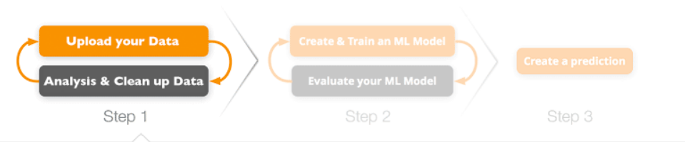

Algoritm

* Supervised
* Unsupervised
* Reinforcement – Agent -> environment with action and reward/sensation

XGBoost is an optimized distributed gradient boosting library designed to be highly ***efficient***, ***flexible*** and ***portable***. It implements machine learning algorithms under the [Gradient Boosting](https://en.wikipedia.org/wiki/Gradient_boosting)

[Apache MXNet](https://mxnet.apache.org/) is a flexible and efficient deep learning platform. It’s particularly suitable for multi-GPU and distributed training across multiple hosts. The [Gluon](https://mxnet.apache.org/gluon/index.html) library in Apache MXNet provides a clear, concise, and simple API for deep learning. Gluon is an imperative and dynamic Python  interface for MXNet, which enables rapid model development, while maintaining MXNet performance

Amazon SageMaker Neo enables developers to train machine learning models once and run them anywhere in the cloud and at the edge.Amazon SageMaker Neo converts the framework-specific functions and operations for TensorFlow, MXNet, and PyTorch into a single compiled executable that can be run anywhere.

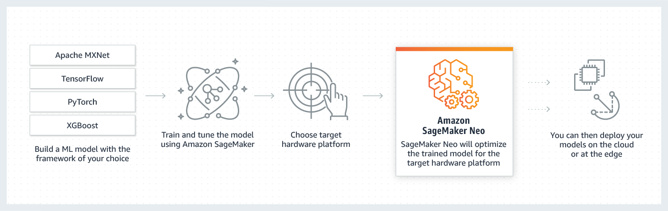

Gradient descent is an optimization algorithm often used for finding the weights or coefficients The goal of the algorithm is to find model parameters (e.g. coefficients or weights) that minimize the error of the model on the training dataset

[Amazon Elastic Inference](https://aws.amazon.com/machine-learning/elastic-inference/), a new service that lets you attach just the right amount of GPU-powered inference acceleration to any Amazon EC2 Here are the high-level steps required to use the service with an Amazon EC2 instance.

1. Create a security group for the instance allowing only incoming SSH traffic.
2. Create an IAM role for the instance, allowing it to connect to the Amazon Elastic Inference service.
3. Create a VPC endpoint for Amazon Elastic Inference in the VPC where the instance will run, attaching a security group allowing only incoming HTTPS traffic from the instance. Please note that you’ll only have to do this once per VPC and that charges for the endpoint are included in the cost of the accelerator.

Machine learning (ML) is split in two distinct phases: training and inference. raining deals with building the model, Inference deals with using the model, i.e. predicting results

Sagemaker

**from** **sagemaker** **import** get\_execution\_role

**from** **sagemaker.session** **import** Session

role = get\_execution\_role()

bucket = Session().default\_bucket()

security

create an IAM role that you attach to the EC2 instance to give applications running on the instance temporary security credentials. The credentials have the permissions specified in the policies attached to the role.

The policy {

"Version": "2012-10-17",

"Statement": [{

"Sid": "AllowCreate-Describe-Delete-Models",

"Effect": "Allow",

"Action": [

"sagemaker:CreateModel",

"sagemaker:DescribeModel",

"sagemaker:DeleteModel"],

"Resource": "\*"

}

],

"Statement": [{

"Sid": "AdditionalIamPermission",

"Effect": "Allow",

"Action": [

"iam:PassRole"],

"Resource": "arn:aws:iam::*account-id*:role/*role-name*"

}

]

}

has two statements:

* The first statement grants permission for three Amazon SageMaker actions (sagemaker:CreateModel, sagemaker:DescribeModel, and sagemaker:DeleteModel) within an Amazon SageMaker notebook instance.

Sagemaker Groud True – make easy label dataset. With Ground Truth, you can use workers from either Amazon Mechanical Turk, a vendor company that you choose, or an internal, private workforce along with machine learning to enable you to create a labeled dataset.

Linear Learner = linear + logistic regression- solving either classification or regression problems

Decision tree – non linear supervised algoritm

XGboost - non linear supervised algoritm

Random forest – ottimo per anomalie

K-means – unsupervised

Anomaly detection

CNN – convolutional – Image Classification

RNN – recurrent output messo come feedback – Sequence to sequence

Time Series - DeepAR

A well-defined machine learning problem, including the following:

* A dataset
* An understanding of the type of algorithm you need to train
* A clear understanding of how you measure success

MONITORING

Amazon CloudWatch monitors your AWS resource

Data Ingestion

**Amazon Kinesis Data Streams** (KDS) INGEST AND STORE DATA is a massively scalable and durable real-time data streaming service. KDS can continuously capture gigabytes of data per second from hundreds of thousands of sources such as website clickstreams, database event streams, financial transactions, social media feeds, IT logs, and location-tracking events. The data collected is available in milliseconds to enable real-time analytics use cases .

Kinesis Streams is capable of capturing large amounts of data (terabytes per hour) from data producers, and streaming it into custom applications for data processing and analysis. Streaming data is replicated by Kinesis across three separate availability zones within AWS to ensure reliability and availability of your data. The more customizable option, Streams is best suited for developers building custom applications or streaming data for specialized needs. The customizability of the approach, however, requires manual scaling and provisioning. Data typically is made available in a stream for 24 hours, but for an additional cost, users can gain data availability for up to seven days.   
You may use Kinesis Streams if you want to do some custom processing with streaming data. With Kinesis Firehose you are simply ingesting it into S3, Redshift or ElasticSearch.

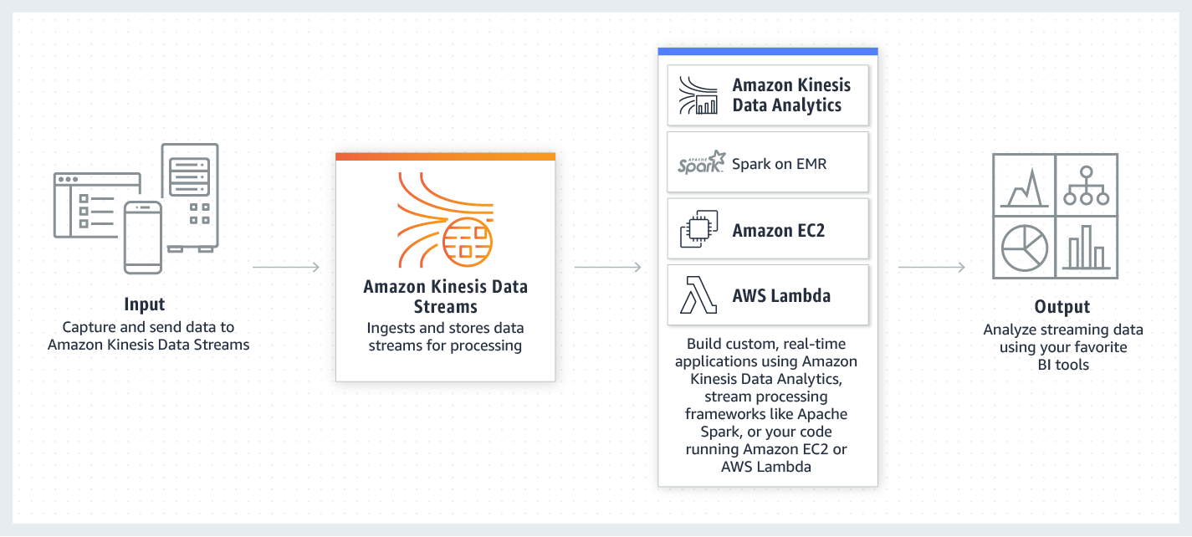

**Amazon Kinesis Firehose is** a fully managed service for delivering real-time streaming data directly to Amazon S3. Kinesis Firehose encryption supports Amazon S3 server-side encryption with AWS Key Management Service (AWS KMS) for encrypting delivered data in Amazon S3. Finally, Kinesis Firehose can invoke Lambda functions to transform incoming source data and deliver it to Amazon S3. It is used to capture and load streaming data into other Amazon services such as S3, Elasticsearch Service and Redshift (Avro, CSV, Grok, Ion, JSON, ORC, Parquet, RCFile, RegexSerDe, SequenceFile, TextFile e TSV), where data can be copied for processing through additional services. It should be noted that Firehose will automatically scale to meet demand, which is in contrast to Kinesis Streams, for which you must manually provision enough capacity to meet anticipated needs. The simpler approach, Firehose handles loading data streams directly into AWS products for processing.

Per aggiungere dati a un flusso di distribuzione Amazon Kinesis Data Firehose, è possibile utilizzare Amazon Kinesis Agent (L'agente monitora determinati file e invia in modo continuo dati nel flusso di distribuzione) oppure i comandi [PutRecord](http://docs.aws.amazon.com/firehose/latest/APIReference/API_PutRecord.html) e [PutRecordBatch](http://docs.aws.amazon.com/firehose/latest/APIReference/API_PutRecordBatch.html" \t "_blank) di Firehose.Kinesis Data Firehose si integra inoltre con altre origini dati di AWS quali Kinesis Data Streams, AWS IoT, Amazon CloudWatch Logs e Amazon CloudWatch Events.

You may use Kinesis Streams if you want to do some custom processing with streaming data. With Kinesis Firehose you are simply ingesting it into S3, Redshift or ElasticSearch.

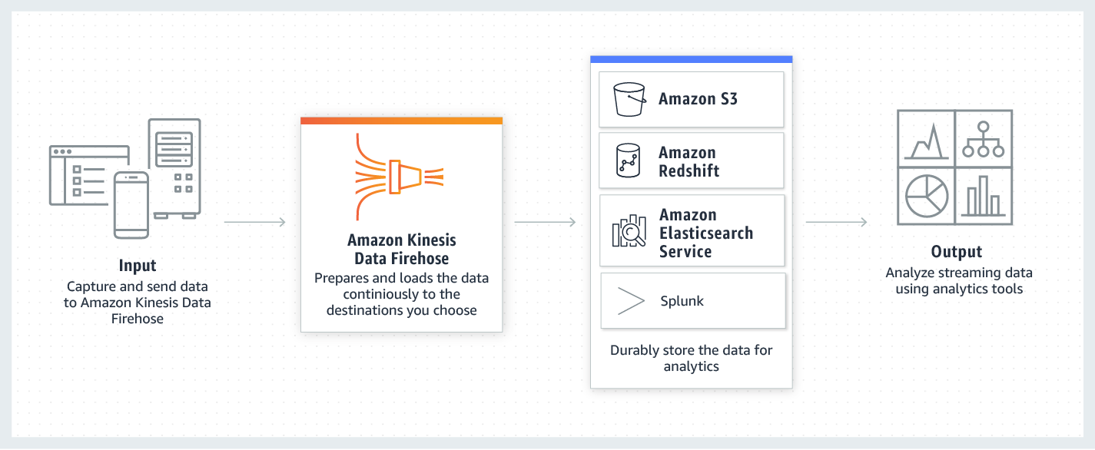

[**Kinesis Data Analytics**](https://aws.amazon.com/kinesis/data-analytics/)Analisi di flussi di dati con SQL standard (o java flink). Powerful Real-time Processing. No Servers to Manage. three simple steps: setup your streaming data sources, write your queries or streaming applications, and setup your destination for processed data.

**Kinesis Video Streams** automatically provisions and elastically scales all the infrastructure needed to ingest streaming video data from millions of devices. It also durably stores, encrypts, and indexes video data in your streams, and allows you to access your data through easy-to-use APIs.

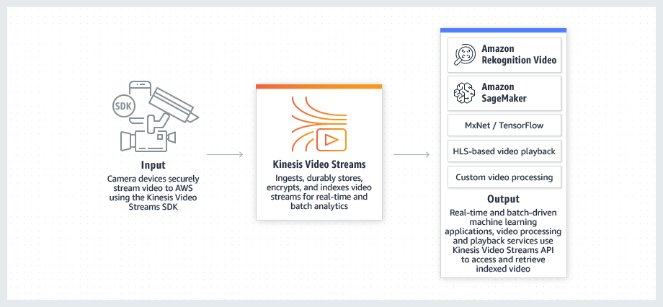

**AWS Snowball**

to securely and efficiently migrate bulk data from on-premises storage platforms and Hadoop clusters to S3 buckets. . PETABYTE. Snowball appliance will be automatically shipped to you. AES-256-bit encryption.

## AWS Storage Gateway

AWS Storage Gateway can be used to integrate legacy on-premises data processing platforms with an Amazon S3-based data lake. he File Gateway configuration of Storage Gateway offers on-premises devices and applications a network file share via an NFS connection. Files written to this mount point are converted to objects stored in Amazon S3 in their original format without any proprietary modification. This means that you can easily integrate applications and platforms that don’t have native Amazon S3 capabilities

## DistCP, which is a standard Apache Hadoop data transfer mechanism. This allows you to run DistCP jobs to transfer data from an on-premises Hadoop cluster to an S3 bucket.

**CRISP DM** cross industry standard process data mining. Business understanding, data understanding, data preparation, modeling, data evaluation , deployment

# Data Transformations

**Recipe** Format Reference: When you create a new datasource in Amazon ML and statistics are computed for that datasource, Amazon ML will also create a suggested recipe that can be used to create a new ML model from the datasource. Groups You can define groups of variables in order to collectively transform all variables within the groups, Assignments You can assign one or more transformations to an intermediate variable, for convenience and readability. Outputs The outputs section controls which input variables will be used for the learning process, and which transformations apply to them. The simplest outputs section simply includes the predefined **ALL\_INPUTS**

"no\_punct(var1)"

"lowercase(var1)"

"osb(var1, 4)" To illustrate, consider the string "The quick brown fox jumps over the lazy dog", and OSBs of size 4.

"The quick brown fox", {The\_quick, The\_\_brown, The\_\_\_fox}

"quick brown fox jumps", {quick\_brown, quick\_\_fox, quick\_\_\_jumps}

"brown fox jumps over", {brown\_fox, brown\_\_jumps, brown\_\_\_over}

"fox jumps over the", {fox\_jumps, fox\_\_over, fox\_\_\_the}

"jumps over the lazy", {jumps\_over, jumps\_\_the, jumps\_\_\_lazy}

"over the lazy dog", {over\_the, over\_\_lazy, over\_\_\_dog}

"the lazy dog", {the\_lazy, the\_\_dog}

"lazy dog", {lazy\_dog}

"ngram(var1, 3)" {"I really enjoyed", "really enjoyed reading", "enjoyed reading this",

"reading this book", "I really", "really enjoyed", "enjoyed reading",

"reading this", "this book", "I", "really", "enjoyed", "reading",

"this", "book"}

"quantile\_bin(var1, 50)" The quantile binning processor takes two inputs, a numerical variable and a parameter called bin number, and outputs a categorical variable.

cartesian(var1, var2)

In [statistics](https://en.wikipedia.org/wiki/Statistics), a **categorical variable** is a [variable](https://en.wikipedia.org/wiki/Variable_(research)) that can take on one of a limited, and usually fixed number of possible values, assigning each individual or other unit of observation to a particular group or [nominal category](https://en.wikipedia.org/wiki/Nominal_category) on the basis of some [qualitative property](https://en.wikipedia.org/wiki/Qualitative_property).[[1]](https://en.wikipedia.org/wiki/Categorical_variable#cite_note-yates-1) In computer science and some branches of mathematics, categorical variables are referred to as [enumerations](https://en.wikipedia.org/wiki/Enumerations) or [enumerated types](https://en.wikipedia.org/wiki/Enumerated_types)

AWS Glue will generate ETL code in Scala or Python to extract data from the source, transform the data to match the target schema, and load it into the target. You can edit, debug and test this code via the Console, in your favorite IDE, or any notebook.

### Model Accuracy EVALUATION

Amazon ML provides an industry-standard accuracy metric for binary classification models called Area Under the (Receiver Operating Characteristic) Curve (AUC). AUC measures the ability of the model to predict a higher score for positive examples as compared to negative examples. The AUC metric returns a decimal value from 0 to 1. AUC values near 1 indicate an ML model that is highly accurate. Values near 0.5 indicate an ML model that is no better than guessing at random.


              image49
            

**Correct Predictions**

* True positive (TP): Amazon ML predicted the value as 1, and the true value is 1.
* True negative (TN): Amazon ML predicted the value as 0, and the true value is 0.

**Erroneous Predictions**

* False positive (FP): Amazon ML predicted the value as 1, but the true value is 0.
* False negative (FN): Amazon ML predicted the value as 0, but the true value is 1.

BINARY classification


                image50
               
                image51
              


                image52
              


                image53
              

MUTICLASS

F1 score is a binary classification metric that considers both binary metrics precision and recall. It is the harmonic mean between precision and recall. The range is 0 to 1. A larger value indicates better predictive accuracy:


                image54
              

REGRESSION


              image56
            

It is a distance measure between the predicted numeric target and the actual numeric answer (ground truth). The smaller the value of the RMSE, the better is the predictive accuracy of the model. A model with perfectly correct predictions would have an RMSE of 0

CROSSVALIDATION

In Amazon ML, you can use the k-fold cross-validation method to perform cross-validation. In k-fold cross-validation, you split the input data into k subsets of data (also known as folds). You train an ML model on all but one (k-1) of the subsets, and then evaluate the model on the subset that was not used for training. T

# hyperparameters or training parameters,

## Learning Rate Learning rate affects the speed at which the algorithm reaches (converges to) the optimal weights

## Model Size you can reduce the model size by using L1 regularization or by specifically restricting the model size by specifying the maximum size.

## Number of Passes The Number of passesparameter controls the number of passes that the algorithm makes over the training data.

## Data Shuffling huffling mixes up the order of your data so that the SGD algorithm doesn't encounter one type of data for too many observations in succession

## Regularization Regularization helps prevent linear models from overfitting training data examples (that is, memorizing patterns instead of generalizing them) by penalizing extreme weight value. L1 regularization has the effect of reducing the number of features used in the model by pushing to zero the weights of features that would otherwise have small weights. As a result, L1 regularization results in sparse models and reduces the amount of noise in the model. L2 regularization results in smaller overall weight values, and stabilizes the weights when there is high correlation between the input features